Unit 1 Review
Fill out the SWOT analysis using each of the subheadings.
Strengths-What have you done well/feel comfortable with
Weaknesses- Areas you need to develop/improve.
Opportunities- How can you increase your grade?
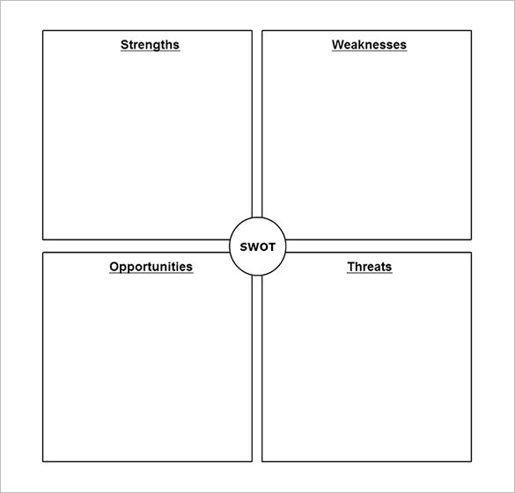
Threats- Ways in which I can support you or deadlines.

