LIFE STAGES: Fill out the key features according to the life stage
LIFE STAGE | AGE | KEY FEATURE
CONCEPTION | 9 MONTHS BEFORE BIRTH
PREGANANCY (gestation) | 9 MONTHS TO BIRTH
BIRTH AND INFANCY | 0 – 3 YEARS
CHILDHOOD | 4 – 9 YEARS
ADOLESCENCE | 10 – 18 YEARS
ADULTHOOD | 18 – 65 YEARS
OLDER ADULTHOOD | 65 YEARS ONWARDS
FINAL STAGES OF LIFE | VARIABLE
Typically what is the definition of life expectancy?
Male Female

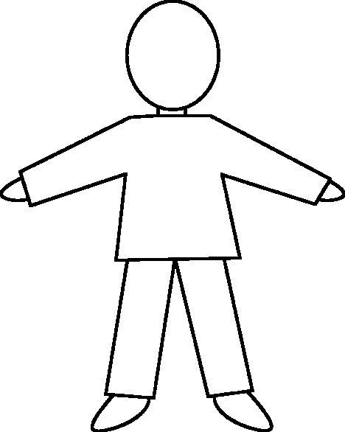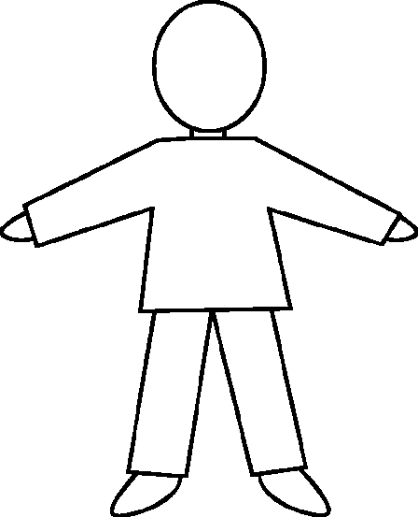
Can you map your life course?

Are you developmentally normal?
Maturation =
Development =
Growth =
What is the difference between growth, development and maturation?

What are developmental milestones? Add your milestones to the timeline below
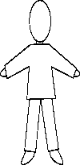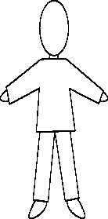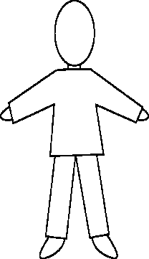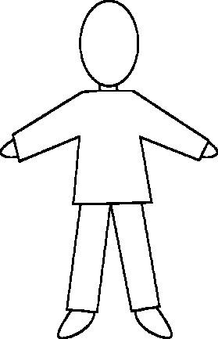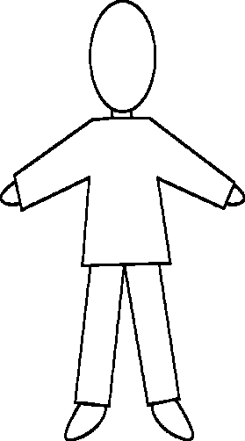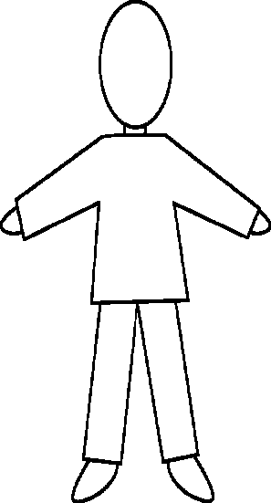

Development of life stages
Physical; Intellectual; Emotional and Social
Very few people experience life factors that fit neatly in to P.I.E.S. Most people experience a life course where all of the factors work together and form a holistic development meaning factors need to be analysed as a whole.
PIES v. Holistic Development

What is the difference between Gross and Fine motor skills?
Physical Development
Infancy 0-2
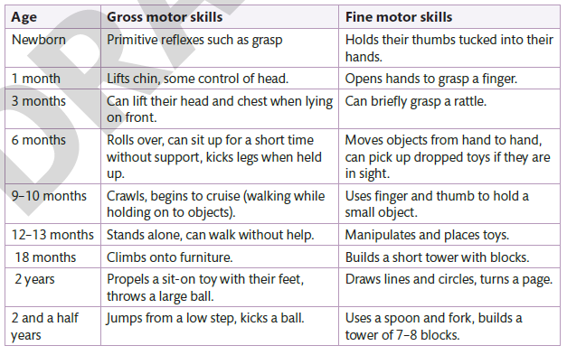

Early Childhood 3-8
How can children aged 3-8 further develop their fine and gross motor skills?

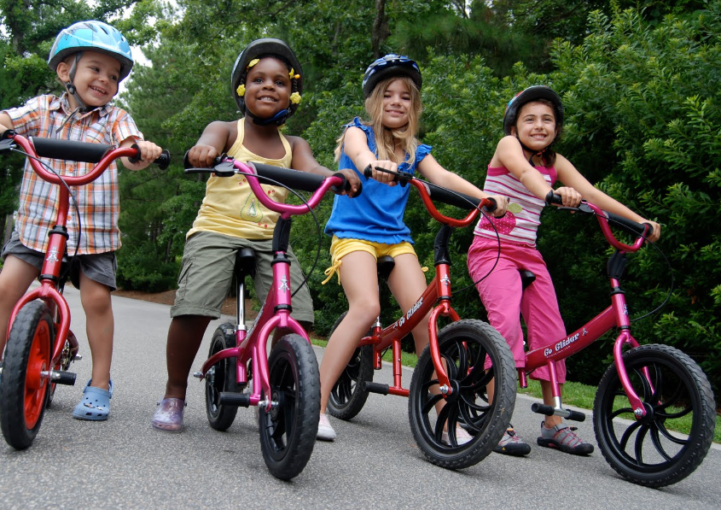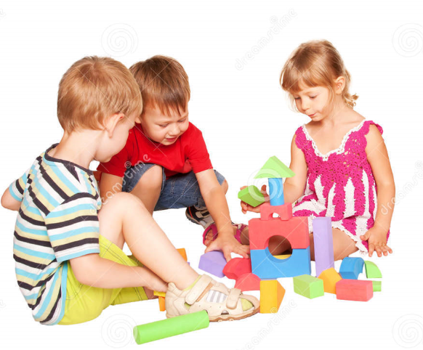

Adolescence 9-18
What are the primary and secondary characteristics for males and females that develop during puberty?
Primary sexual characteristics |  | Secondary sexual characteristics
Female | Male | Female | Male

Early adulthood 19-45
Between 19 and 28 adults reach their full peak of physical performance, after this age adults tend to lose some of their strength and speed; Diet too can exaggerate this...
Pregnancy and lactation - During this phase hormonal changes take place and an increase in progesterone which maintains pregnancy. An increase in oestrogen can also be responsibility for the sickness. Hormones can affect shape and appearance of a woman’s breast including darkened veins due to increased blood supply. Nipples darken and become more sensitive and tender preparing the breasts to produce milk.
Perimenopause often occurs during Middle adulthood which looks at the development of 45-65 years but we need to focus on perimenopause which occurs in woman as this leads on to menopause which typically occurs in middle adulthood.
By 40 years old typically a woman gradually begins to make less oestrogen, meaning she will eventually stop producing an egg each month. Perimenopause will occur until menopause begins which is the point at which eggs are no longer produced. Perimenopause can last up to 4 years but can for some woman last as long as ten years. Perimenopause ends when a woman has not released an egg for more than 12 months.

Middle Adulthood 45-65
Menopause
Watch the following video clip and consider the questions below, you will have time to answer this after the clip https://www.youtube.com/watch?v=U8UWOuOjZ-4
?
What age does menopause typically occurs? ....................................................................................................................................................
What does it mark the end of? ....................................................................................................................................................
What hormone is no longer produced? ....................................................................................................................................................

What are the physical complaints that occur during menopause?
............................................................................................................................................................................................................................................................................................................................................................................................................................................................
What is a prolapse and what are the symptoms? ............................................................................................................................................................................................................................................................................................................................................................................................................................................................
What are the psychological complaints that occur during menopause? ............................................................................................................................................................................................................................................................................................................................................................................................................................................................
What food should you keep to a minimum? ....................................................................................................................................................
What should you increase to avoid osteoporosis? ....................................................................................................................................................
What is osteoporosis? ........................................................................................................................................................................................................................................................................................................
EXT: Can you link evolutionary psychology to menopause? ................................................................................................................................................................................................................................................................................................................................................................................................................................................................................................................................................................................................................
Create a case study that (using your own words) that describes perimenopause and menopause.

Middle aged Spread
This refers to weight gain in middle adulthood possible due to adults still eat the same amount of food as they did when they were younger but don’t exercise as much or their metabolism has slowed down.
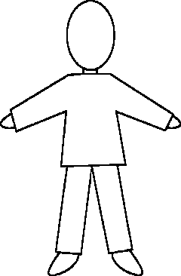
Demonstrate on your character below what other physical traits you might expect to see in middle adulthood.

Later adulthood 65+
For revision for LO3 list below some of the physical changes that occur in later adulthood

Intellectual development
Chomsky and Pinker believe that the ability to communicate through verbal and non-verbal communication is preprogramed. Chomsky stated that we are born with language acquisition that enables us to recognise and develop language that we experience. Our ability to learn language is genetically programmed to develop in the same way as we are programmed to lean to talk.
Memory
Language Development
Problem Solving

Abstract thoughts
Moral development

How can you encourage language development for infants, young children and adolescents?
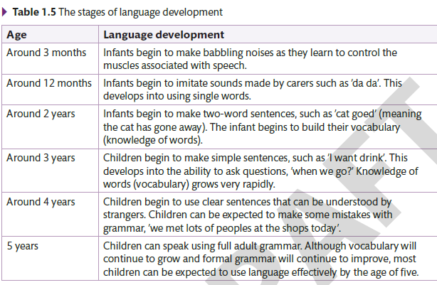

Piaget’s model of intellectual development
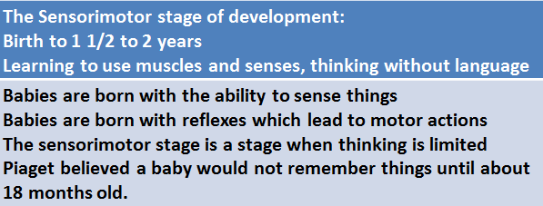
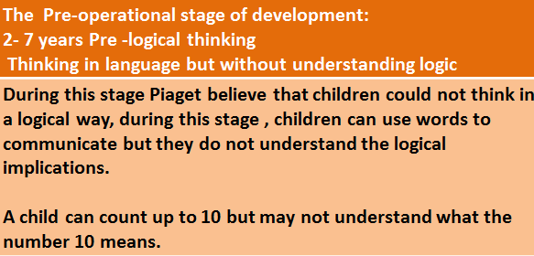
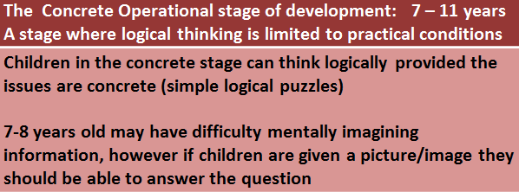
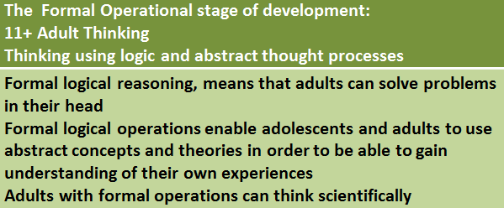

The development of schemas
An important aspect of Piaget’s cognitive devlopment was the notion that chidlren go through a series of intellectualy development. These stages are called schema which is a category of knowledge. A child devlops concepts about the world around them (a state of equilibrium). As children are presented with new infomration they have to balance what the know with new infomration and often they reach a period of unsettlement known as disequilibrium. As new information is introduced and schmas are changed and accomodated children will return to a state of equilibrium.
Research the following terms – what do they mean and how do the help us find out more about the child and how we develop?
Egocentrism

Chomsky’s model of langugage acquision

Langugage acquistion device

Tests of conversion
Children understand the theory of conversion that is that something appearance may change but the volume will remain the same. Children will begin to understand below from age 7.
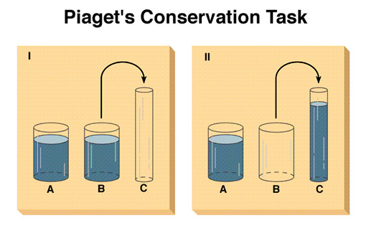
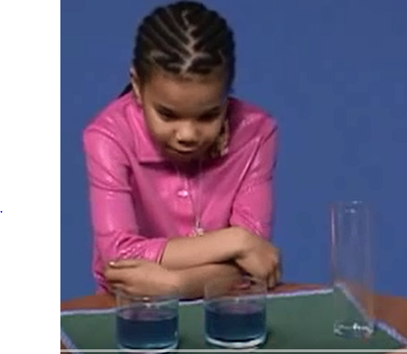
Watch the conservation task: https://www.youtube.com/watch?v=YtLEWVu815o
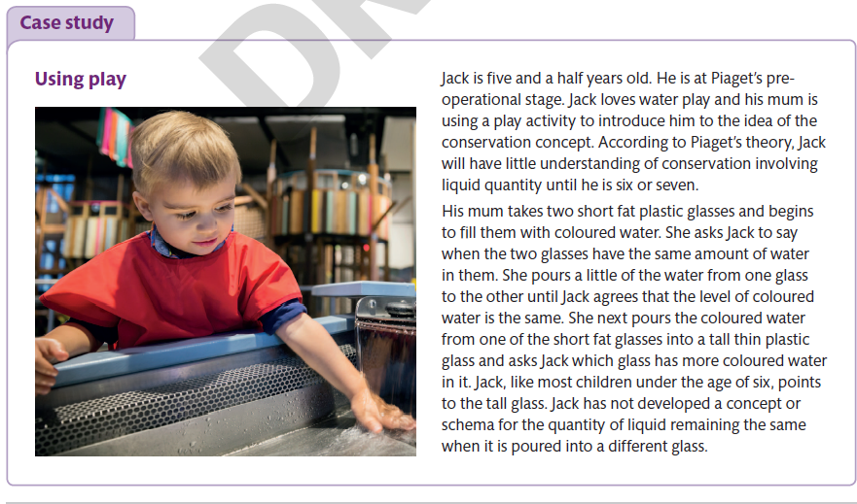

Emotional Development
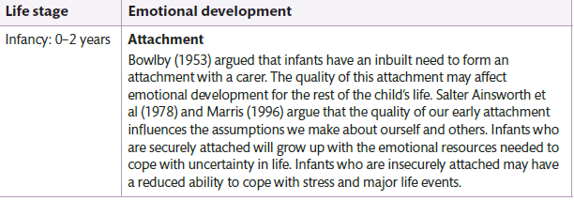

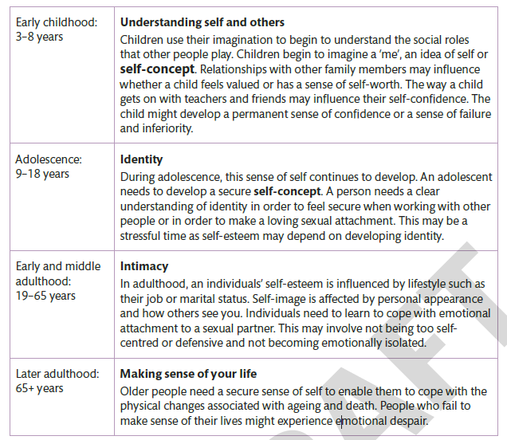

Write a fact sheet about Bowlby’s 1930’s research on attachment and Mary Ainsworth’s stranger situation classification and Schaffer and Emerson’s 1964 sequence of attachment. Include the diagram below in your own words -
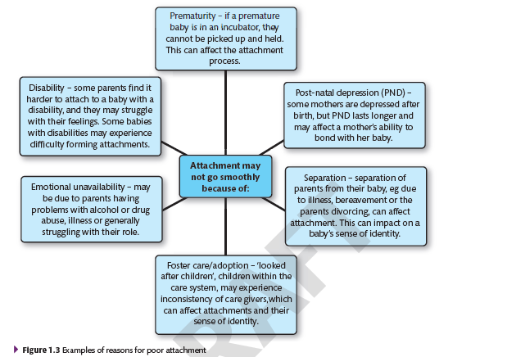

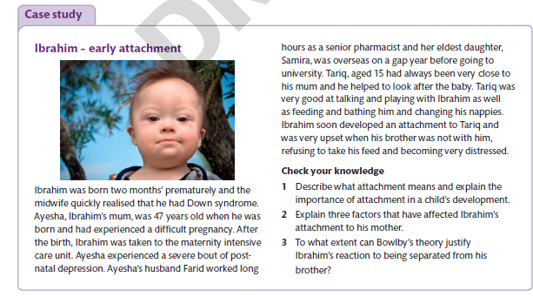

Adolescence 9-18
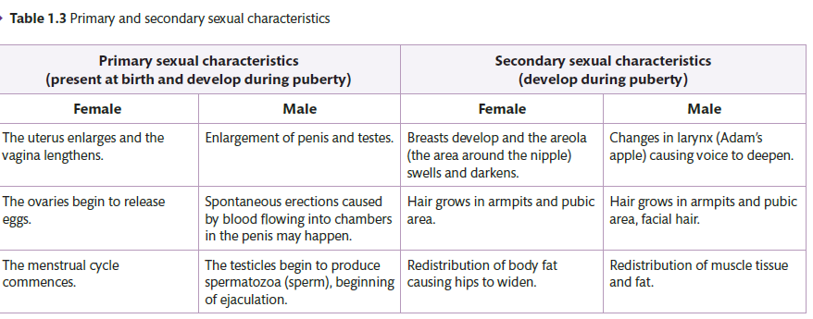

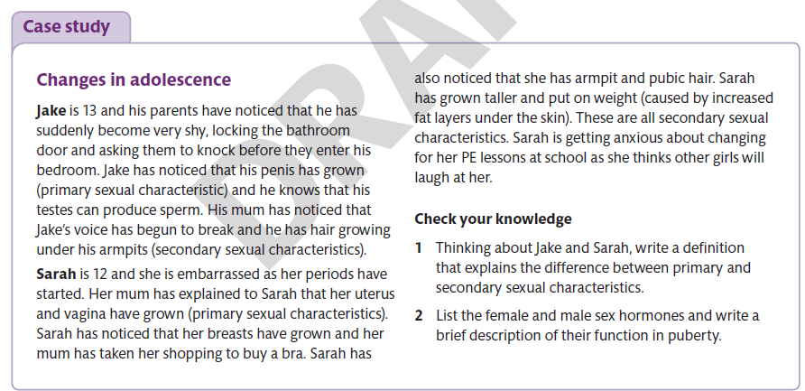

Why is our self-esteem so important to our development? Who can influence it and what impact can they have?
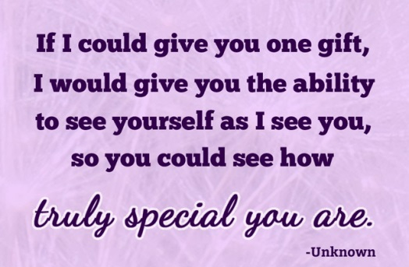
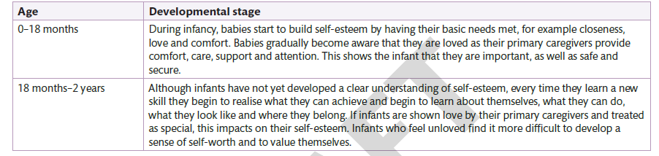
How does your self-concept change as you age? Remind yourselves of self-image?
?

Determined in early childhood by the quality of social interaction and the influence of parents and caregivers. A parent who makes positive comments in a consistent way will lay the foundations for a positive self-image (Billingham et al. 2016).
An individual’s self-image can be real or distorted of which they actually are its does not necessarily affect reality feeling about image can become internalised and affect how an individual acts. (Billingham et al. 2016).

Create a case study that includes some of the factors that would affect the emotional development within middle adulthood? Making reference to their self-concept and self-image? Meeting someone and starting a relationship, marriage, having children, bereavement, making and/or loosing friends…

Extension task – research your adult relationship based on your attachment using the following quiz (there are 50 questions and it will take approx. 20 mins) http://psychologytoday.tests.psychtests.com/take_test.php?idRegTest=3265
?

Social development
What are the stages of play in infancy and early childhood and how do they help children develop?
Cooperative Play
Parallel Play

For all individuals throughout their life stages there are benefits do making and keep friends, what are they are why?

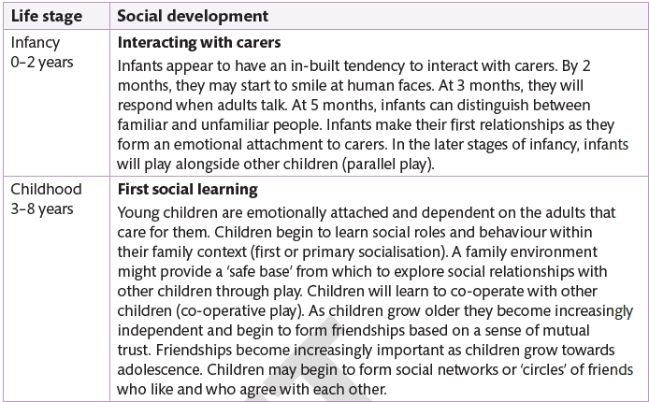
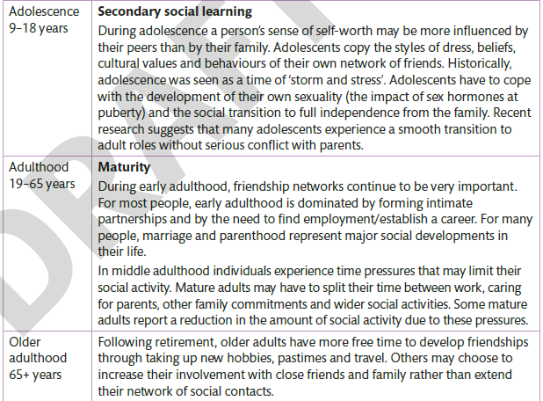

During these stages think about what life events occurs and how that can affect our emotional and social development, e.g. getting married and having a baby.
Application of learning
?
Answer the following questions as exam questions:
- George is 65 years old and lives with his wife Polly, who is 53 years old, their adult daughter Nita, is 19 years and has foetal alcohol syndrome. What are the physical changes that will occur for George and Polly (6marks)
- George is soon to retire from his job as a manger which he had held for 35 years, explain two possible effects of Georges retirement on his emotional development (4marks)
- Due to Nita’s care needs Polly did not return to her career as a nurse after Nita’s birth, recently she has considered retuning to nursing. To what extend will George’s retirement from a senior role affect Polly’s self-image (10 marks)
- Polly has decided to leave George and the family home, leaving George as Nita’s sole carer. Evaluate the effects of ageing on George’s ability to care for Nita (10 marks)
Remember plan, do and review…
Plan – what am I being asked to do, think about this carefully, read the question and answer what is being asked, don’t rewrite the question.
Do – have you considered all parts and components of the questions have you referred to all individuals in the question/case study?
Review – I can explain how I answer the question and the conclusion that I have drawn.
Extension Activity
Write your own exam questions and model answers for revision – working in small groups you will be given one area of development, think of questions that might appear in the exam and consider an answer and appropriate marks scheme too.

