Part 1
Josh and Nikki live in Derbyshire with their two children, Isabelle and Sophie. The girls are twins, both aged 6.
The family live in a rented house with two bedrooms. Josh works at the local supermarket and often has to work shifts which are long and can be unsociable hours. He earns just a little over the minimum wage but is pleased that the supermarket is only 1 mile away. Nikki hasn’t been able to go back to full time work since the girls were born but she is able to earn a little money each week doing people’s ironing and some cleaning whilst the children are at school.
Below is a list of the expenses that the family have to pay and their income each week .
Your task is to work out how much money they have left over at the end of the month. The family would like to save some money for a camping holiday this year.
YOU MUST SHOW YOUR WORKING OUT! Do this on the next page
Assume there are 4 weeks in each month
Item | Cost per month/week
Rent | £250 per month
Power (gas/electric) | £15 per week
Council tax | £100 per month
Mobile phone | £45 per month
Food | £380 per month
Going out | £50 each weekly (Josh and Nikki)
Petrol and car costs | £100 per month

Each month Josh earns £ 1683 after tax per month.
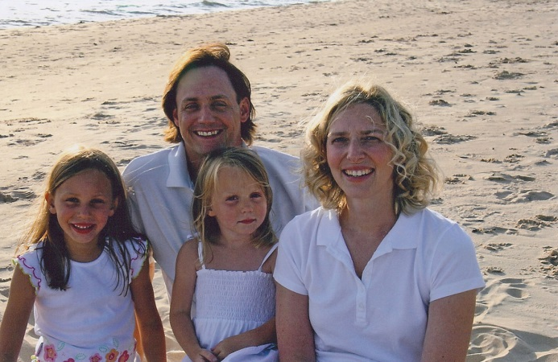
Nikki earns £300 per month.

Josh and Nikki
Combined income per month – Combined expenses per month =
____________________________________________________________________________________________________________________________________________________________________________________________________________________________________________________________________________________________________________________________________________________________________________________________________________________________________________________________________________________________________________________________________________________________________________________________________________________________________________________________________________________________________________________________________________________________________________________________________________________________________________________

Part 2
Just after Christmas the supermarket that Josh works at had a meeting with all of the staff. They said that because December’s sales hadn’t gone as well as they had expected, they will need to cut down on people’s hours. This meant that Josh would only be able to work half of the hours that he used to.
Calculate how much Josh will now be earning per month

__________________________________________________________________________________________________________________________________________________________________________________________________________________________________________________________________________________________________________________________________________________________________________________________________________________________

What problem does the family now have financially?
__________________________________________________________________________________________________________________________________________________________________________________________________________________________________________________________________________________________________________________________________________________________________________________________________________________________

Part 3
It looks like their financial situation will be like this for quite a while. They have come to you for some help and advice.
a) Look again at the family’s expenses. What do you think they could cut down on in order to meet the bills that they have to pay? (hint – first of all, decide on the bills that they can control and those that they cannot). How much money do they need to be able to survive? What extra things could they do to cut down on their expenses?
____________________________________________________________________________________________________________________________________________________________________________________________________________________________________________________________________________________________________________________________________________________________________________________________________________________________________________________________________________________________________________________________________________________________________________________________________________________________________________________________________________________________________________________________________________________________________________________________________________________________________________________________________________________________________________________________________________________________________________________________________________________________________________________________________________________________________________________________________________________________________________________________________________________________________________________________________________________________________________________________________________________________________________________________________________________________________________________________________________________________________________________________________________________________________________________________________________________________________________________________________________________________________________________________________________________________________________________________________________________________________________________________________________________________________________________________________________________________________________________________________________________________________________________________________________________________________________________________________________________________________________________________________________________
______________________________________________________________________________________________________________________________________________________________________________________________________________________________________________________________________________________________________________________________________________________________________________________________________________________________________________________________________________________________________________________________________________________________________________________________

Part 4 – The future
Thanks to your helpful advice the family are able to cope until Josh can increase his hours. However, we don’t know when that will be. As health and care workers we have to think about how this situation will affect the family in other ways.
a) Having to cut down on their grocery bills might mean the family cannot have as much fresh fruit and veg as they used to. How might this affect them physically?
__________________________________________________________________________________________________________________________________________________________________________________________________________________________________________________________________________________________________________________________________________________________________________________________________________________________
b) Josh is a proud man and he has always been confident that he could provide for his growing family. How might this affect him emotionally? Can you predict any problems that Josh and Nikki might have emotionally due to this financial stress?
____________________________________________________________________________________________________________________________________________________________________________________________________________________________________________________________________________________________________________________________________________________________________________________________________________________________________________________________________________________________________________________________________________________________________________________________________________________________________________________________________________________________________________________________________________________________________________________________________________________________________________________

c) Nikki, Josh and the girls have always enjoyed quite an active social life. The girls have been able to go horse riding and the couple have always gone out at the weekend to the pub to see their friends. Now that Josh is earning less, this will be affected. How might their money situation affect their social development? What could they do instead that is within their budget?
____________________________________________________________________________________________________________________________________________________________________________________________________________________________________________________________________________________________________________________________________________________________________________________________________________________________________________________________________________________________________________________________________________________________________________________________________________________________________________________________________________________________________________________________________________________________________________________________________________________________________________________
d) Josh and Nikki have never really had to budget as tightly as this before. How might this affect their intellectual development?
____________________________________________________________________________________________________________________________________________________________________________________________________________________________________________________________________________________________________________________________________________________________________________________________________________________________________________________________________________________________________________________________________________________________________________________________________________________________________________________________________________________________________________________________________________________________________________________________________________________________________________________

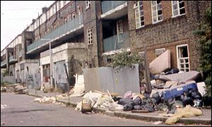
Oh dear! – It got worse for Josh, Nikki and
the girls. Josh lost his job when the
Supermarket closed down. They had to move
to another house in a different area.

The new house was a lot cheaper but it was in an area that had a very high crime rate. It was dirty and everywhere there were dirty needles and rubbish. The girls were afraid to walk to school and Nikki also lost her contacts for the ironing and cleaning business. Josh is looking for work. Thankfully they do have a little money from Josh’s redundancy pay but it is only enough to cover their very basic needs. The landlord has left the property in a bad condition with broken windows and no locks on the doors. Every night they family are kept awake by the sounds of fighting and loud music. The house doesn’t have a fully working heating system and hot water must be boiled in the kettle.
You have now been assigned to the family as their care worker. You have read their files but haven’t actually met them.
As you are part of a team you should work together in a small group to build up a picture of the problems that they now face in order to help them. On the next page is the form you must fill out.
Start with the twins and then move on to Mum and Dad.

Isabelle and Sophie
Aspect of development affected | Description of the concern
Physical development (physical health, sleep, nutrition and growth, hygiene)

Intellectual development (education, homework, knowledge of the world around them)

Emotional development (confidence, bonding with family and friends, feelings of self worth/self image)

Social development (role models, social interaction or isolation)

Josh and Nikki
Aspect of development affected | Description of the concern
Physical development (physical health, sleep, nutrition and growth, hygiene)

Intellectual development (education, homework, knowledge of the world around them)

Emotional development (confidence, bonding with family and friends, feelings of self worth/self image)

Social development (role models, social interaction or isolation)

Congratulations!!
Your hard work has paid off and this story has a happy ending. You made some suggestions and they worked.
What ending would you write for this family? Did the girls make friends? Did they move back to their old area? Did Josh and Nikki find work? What impact did the changes you made have on their lives?
____________________________________________________________________________________________________________________________________________________________________________________________________________________________________________________________________________________________________________________________________________________________________________________________________________________________________________________________________________________________________________________________________________________________________________________________________________________________________________________________________________________________________________________________________________________________________________________________________________________________________________________________________________________________________________________________________________________________________________________________________________________________________________________________________________________________________________________________________________________________________________________________________________________________________________________________________________________________________________________________________________________________________________________________________________________________________________________________________________________________________________________________________________________________________________________________________________________________________________________________________________________________________________________________________________________________________________________________________________________________________________________________________________________________________________________________________________________________________________________________________________________________________________________________________________________________________________________________________________________________________________________________________________________________________________________________________________________________________________________________________________________________________________________________________________________________________________________________________________________________________________________________________________________________________________________________________________________________________________________________________________________________________________________________________________________________________________________________________________________________________________________________________________________________________________________________________________________________________________________________________________________________________________________________________________________________________________________________________________________________________________________________________________________________________________

